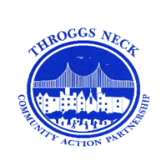
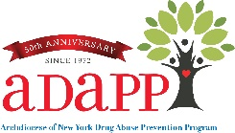


In addition, there will be an Interactive Activity
“Hidden in Plain Sight” in the vestibule of the lobby.
6:00 pm – 6:30 pm
This activity is intended for adults over the age of 21.
Find out how to identify clues from a teen’s bedroom whether they might be experimenting with or using drugs or alcohol. See if you can find how many items are located throughout the room and hidden in plain sight.

Throggs Neck Community Action Partnership - TNCAP
Presents
A Community Town Hall Meeting
“Understanding the Effects of Substances of
Abuse and Behaviors on the Adolescent Brain”

Keynote Speaker: Dr. Stephen Dewey
Neuroscientist, Research Professor, and President, Addiction Educators, LLC

Followed by a Q &A Panel Discussion
Hear from experts in our community representing Community Board 10, Substance Prevention, Law Enforcement, Education, and the Office of the Bronx DA and others.
Visit our resource table for free prevention materials.

Thursday, March 2, 2023
Interactive Activity - 6:00 pm - 6:30 pm
Presentation & Panel Discussion - 6:30 pm - 8:00 pm
PS 72 - Auditorium
2951 Dewey Avenue, Bronx, NY 10465
Light refreshments will be served.

The event is free, to register you can use the QR code or click here.
If you need further assistance registering, please contact
Dawn Insanalli, at 718-904-1333 Ext. 16
dinsanalli@adapp.org



